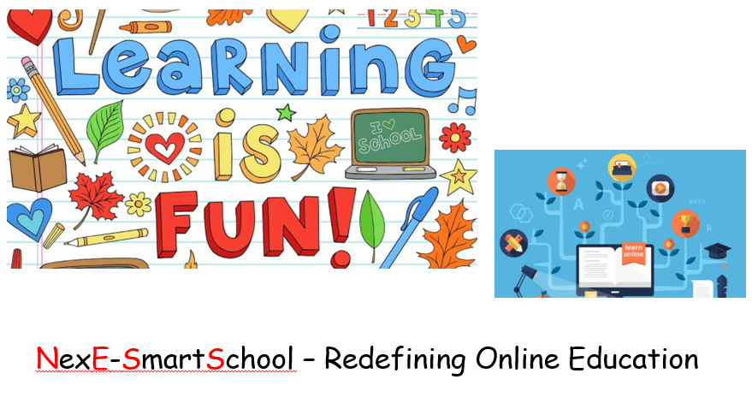

NexE-SmartSchool – A new Definition in Online Tutoring

About us:
We are a start-up firm (based in Kerala, India) rapidly expanding and offer live one-on-one tutoring to students all over the world. We support students from Grade 1 to University level and Engineering. We do tutoring in Computer/Math/Science/English/French to students in Elementary School/ Middle School/ High School/ and Senior Secondary levels. We focus on different curricula like Australia, US, UK (GCSE, IGCSE, IB, O, A & AS levels) and CBSE. We do support Home-work, Project-Works/ Seminar/ Content Development/ Other Academic level requirements.
Also we support IT Projects like Office Automation, Web page design, Accounting using Excel (for Small-Medium Firms), and Power Point Presentations etc.
For more info please login to: http://smartschool.nexeonsoft.com

Tutoring Medium:
Skype is the Primary medium for communication (also using Google Hangouts, TeamViewer etc.). We are using Customized Whiteboards etc. for additional support.

Free demo for half an hour. Take this opportunity and really enjoy quality tutoring with low cost at your home comfort itself. Avoid the inconveniences of Timing/Moving to Tutoring locations/Adjusting Tutor at Home/conflicts of quick schedule changes etc. ….

We Handle the following Curricula:
Australia | Math (All Area)/ Science (Physics, Chemistry, Biology)/ Geography / Language (English, French)
CBSE/ICSE | Math (All Area)/ Science (All Area)/ Social Studies/ Computer Science (C, C++, Java, Python, HTML, SQL)/ Accountancy/ Language (English, Hindi, French, Tamil & Malayalam)
US | Math (All Area)/ Science (All Area)/ Humanities/ Computer Science (C, C++, Java)/ Accounting/ Language (English)
UK | Basic, GCSE, IGCSE, IB, O Level, A Level, AS level
Test Prep. | AP, ACT, SAT (1 & 2), IELTS, TOEFL
IT | C, C++, JAVA, MS Office (Word, Excel, PowerPoint, Access), SQL

We Support the following Grades:
Primary | Regular Session, Home-work Solution, Numerical Techniques
Elementary | Regular Session, Home-work Solution, Numerical Techniques
Middle School | Regular Session, Home-work Solution, Numerical Techniques, Question Paper Review
High School | Regular Session, Home-work Solution, Question Paper Review, Offline Problem Solution, Project Work
Secondary | Regular Session, Home-work Solution, Question Paper Review, Offline Problem Solution, Practical, Project Work, Seminar
Graduation | Regular Session, Assignment Solution, Question Paper Review, Offline Problem Solution, Practical, Project Work, Seminar
Engineering | Regular Session, Assignment Solution, Question Paper Review, Offline Problem Solution, Practical, Project Work, Seminar, Prototype Testing

Tutor Profile
Area | Qualification | Experience | Other
Math & Science | (i) Post-graduation in respective Area  (ii) Graduation in Education | (i) 5+ Years of Teaching experience in Institutes  (ii) Freelance Tutoring Experience for 5+ Years
Language | (i) Post-graduation in respective Area  (ii) Graduation in Education | (i) 3-5 Years of Teaching experience in Institutes  (ii) Freelance Tutoring Experience for 5+ Years | Grade (Level) Certification in specific Language
Engineering | (i) Post-graduation in Electronics Engineering  (ii) Post-graduation in Computer Sci. & Engineering | (i) 5+ Years of Teaching experience in Engg. Colleges  (ii) Freelance Tutoring Experience for 5+ Years | Participation in International Seminars

Other Service NexE-SmartSchool Offers:
IT Training | C, C++, JAVA, MS Office (Word, Excel, PowerPoint, Access), SQL, Macro/Scripting in Excel, Visual Basic, FoxPro
IT Project Support | Office Automation, Web page design, Accounting using Excel (for Small-Medium Firms), and Power Point Presentations
Blog | Content Development (Academic, Technology)

